Exercise 2

1. Display the Supplier table in the descending order of CITY.

SELECT * FROM S ORDER BY City desc;

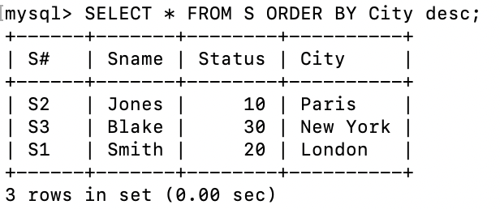

2. Display the Part Table in the ascending order of CITY and within the city in the ascending order of Part names.

SELECT * FROM P ORDER BY City ASC, Pname ASC;

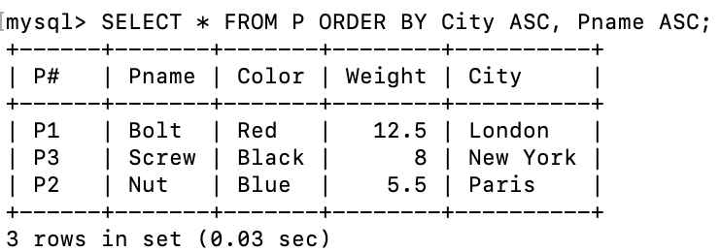

3. Display all the Suppliers with a status between 10 and 20.

SELECT * FROM S WHERE Status BETWEEN 10 AND 20;

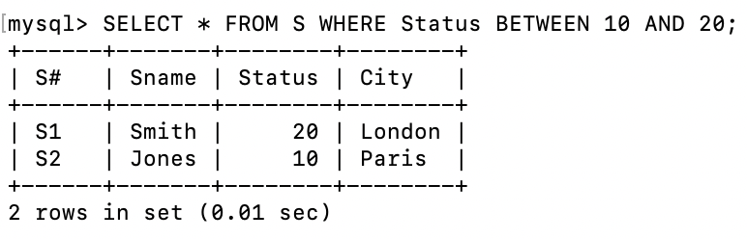

4. Display all the Parts and their Weight, which are not in the range of 10 and 15.

SELECT Pname, Weight FROM P WHERE Weight NOT BETWEEN 10 and 15;

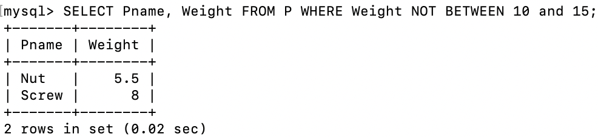

5. Display all the Part names starting with the letter 'S'.

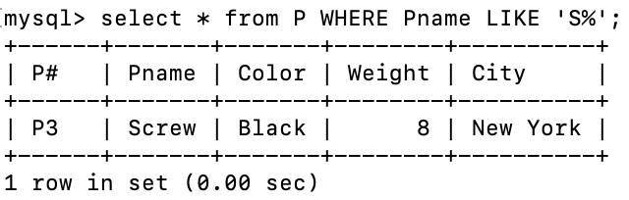

6. Display all the Suppliers, belonging to cities starting with the letter 'L'.
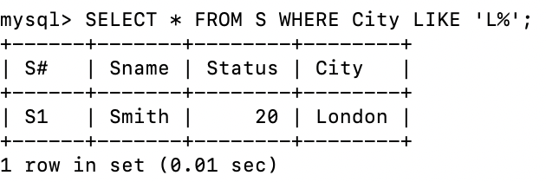

7. Display all the Projects, with the third letter in JNAME as 'n'.

SELECT * FROM J WHERE Jname LIKE '___n%';

